**Faculty of Computing Year 2 Semester 1 (2025)**

**IT2120- Probability and Statistics**

**Lab Sheet 07**

**IT24102513**

**Ranjanaramya L**

**Exercise**

1.

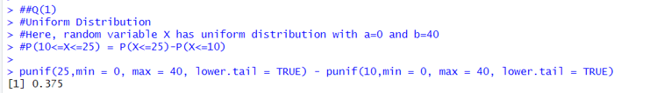

2.

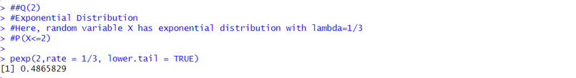

3.

(i)

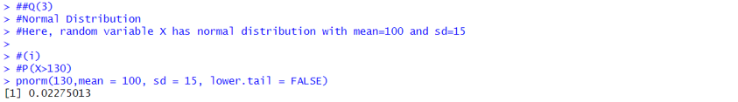

(ii)



